Session 02 SQL Basics & CommandsTrainer Coverage:SQL syntax rules.DDL commands: CREATE, ALTER, DROP.Creating basic users and expenses tables.Demo: Execute commands in MySQL CLI / Workbench.

Q:-01 Open MySQL Workbench or CLI and write a CREATE TABLE statement to create a table called 'restaurants' with columns: id (INT, primary key, auto-increment), name (VARCHAR(100)), location (VARCHAR(100)), and rating (DECIMAL(2,1)).

create table restaurants(
id integer primary key auto_increment,
name varchar(100),
location varchar(100),
rating real);

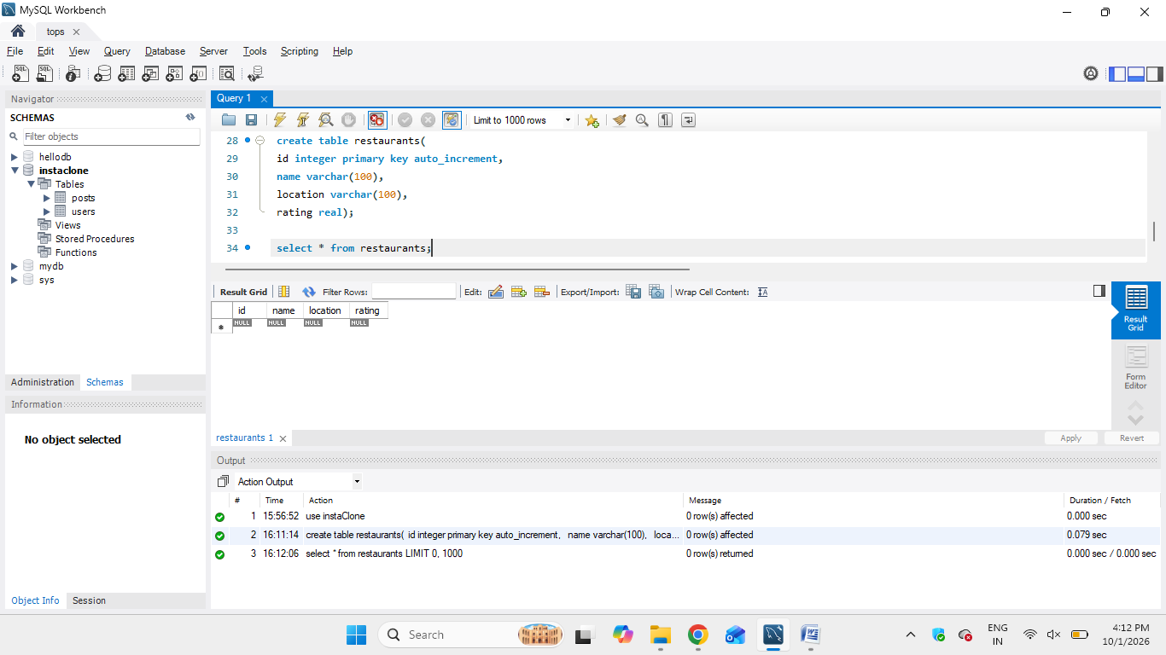
Q:-02 Use the ALTER TABLE command in MySQL to add a new column 'average_cost' (INT) to your 'restaurants' table.Remember to specify the data type when adding a new column.

alter table restaurants add column average_cost integer;
insert into restaurants (name, location, rating,average_cost)
values
('lapinoz', 'dubai', 4.5,500),
('flavours', 'Rajkot', 4.8,800),
('Sankalp', 'Surat', 3.0,1000);
SELECT * FROM restaurants;

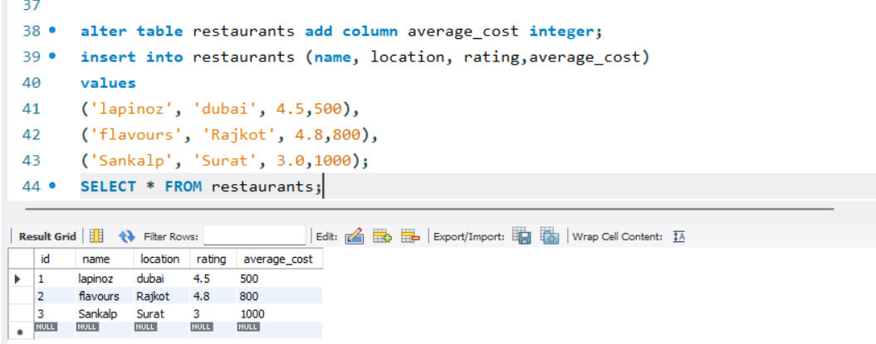

Q:-03 Write a SQL statement to DROP the 'restaurants' table you created earlier. Double-check your command before running it to avoid accidental data loss.

drop table restaurants;

Q:-04 Create a new table called 'playlists' for a music app like Spotify, with columns: playlist_id (INT, primary key, auto-increment), title (VARCHAR(50)), created_by (VARCHAR(50)), and created_at (DATE).

create table playlists (
playlist_id integer primary key auto_increment,
title varchar(50),
created_by varchar(50),
created_at date);

